

**Project Report**

**Extensible Messaging and Presence Protocol (XMPP)**

**By**

**“Team 14”**

**Under the guidance of:**

**Prof. Shai Silberman**

**CMPE 208-01, Spring 2016**

**San Jose State University**

Team members

Omkar Rege

Ankur Sheth

Girish Bangalore Ramesh

Avinash Closepet Suresh

# Abstract

The project report focuses on Extensible Messaging and Presence Protocol (**XMPP**). XMPP is a communication protocol with open standard for messaging and presence. It enables real time transfer of data between two network entities. It’s a language independent software for every platform and libraries. This provides basic presence, message and routing features. This open standard is suitable for all latest technology like IOT, smart grid, WebRTC and networking. XMPP is robust and powerful as its architecture is decentralized. It provides near real time communications through text, audio and video.  Many social networking platforms uses XMPP such as Facebook, what’s app, Gtalk and yahoo. The Core XMPP is explained in [RFC 6120] and XMPP message format is explained in [RFC6122]. XMPP is one of the continuously improving standards. In order to perform the XMPP Lab, we have used OpenFire (version 4.0.2) server and Spark (version 2.7.7) IM client so as to study and generate the XMPP traffic.

# Contribution of each team member

|  |  |  |
| --- | --- | --- |
| **Student ID** | **Team Member** | **Contribution** |
| 010120240 | Girish Bangalore Ramesh | Abstract, Introduction, Overview |
| 010739924 | Ankur Sheth | Lab environment setup, Lab Execution, Observations |
| 010720398 | Omkar Rege | Observations, Packet Captures |
| 010129483 | Avinash Closepet Suresh | Architecture, Standards, Conclusion, References |

Although the above table shows individual team member’s contribution in performing this lab, every member has tried to put in his efforts equally in completing the lab and drafting the lab report.

**Table of Contents**

Abstract 2

Contribution of each team member 2

Introduction 4

Motivation for XMPP 7

Overview 7

XMPP Architecture 7

XMPP Implementation 13

Lab Environment setup 15

Captured XMPP packets 23

Conclusion 31

References 32

# Introduction

XMPP is a communication protocol with open standard for messaging and presence. It enables real time transfer of data between two network entities. It’s a language independent software for every platform and libraries. XMPP is basically designed for instant messaging and information presentation.

Now XMPP can support for Voice over IP, message oriented middleware and also file transfer. Current applications use XMPP extensible.

XMPP is an open standard by IETF and its been continuously extended by the standard foundation.

**The main features of XMPP are as follows:**

* It’s a decentralized network. We can set up a XMPP server and have their clients and services connected to it.
* XMPP server and client implementation are readily available by many open source contributors and there are many plugins available for providing various gateway services.
* New messages and services can be easily extended in the XMPP
* Custom extensions are also possible.

XMPP can be categorized for two:

1. Services
2. Application

**Services:**

This is a kind of functionality which can be incorporated by other applications. Few of the services are as follows:

* Channel Encryption
* Peer-to-peer media sessions
* Authentication
* Presence
* Contact List
* Notifications
* One-to-one messaging
* Multi-party messaging

Detailed explanation about services is as below:

**Channel encryption:** To build a secure connection channel it’s important that the client-server or the server-server is encrypted.

**Authentication:** A clients trying to connect to the server must have an authentication system. It’s always safe to have a secure connection.

**Presence:** This is used to find other entities in a given area. This gives information about status of the user.

**Contact lists:** This service is used to maintain a list of entities on a server. One-to-one messaging Instant messaging applications uses this service to send and receive messages between them.

**Notifications:** Notifications are instant alert messages on any entity.

**Service discovery:** This can be used to find the services provided by other entities and to find the services used by others.

**Peer-to-peer:** This manages the services like instant messaging, video chat etc. connection between other entities.

**Applications:**

We can use the core XMPP services to build custom applications like:

* System control
* Group chat
* Gaming
* Instant messaging
* Geo Location
* Middleware and cloud computing

Below is a list of applications built using XMPP:

**Instant messaging:** The core services like Contact list, presence and one-to-one messaging can be used to build an application using XMPP.

**Geo-location:**  Maps or tracking can be integrated using the notification service by having geo-location as payload in XMPP.

**Cloud computing:** This XMPP service can be used for lightweight communication, calculation, and cloud management.

**Voice over IP:** Jingle which is the XMPP media session is used here. Google talk used XMPP for VOIP for the first time.

**Identity services:** Jabber ID can be used for identifying services. These services like Jabber can use XMPP in building their identity.

**Gaming:** One-to-one messaging and multi-party messaging and extensions are the core components used to build gaming application.

**Types of Messages:**

Chat: One-to-one conversation.

Error: If any error has occurred w.r.t the previous messages.

Group chat: It’s the messages in multiuser chat application.

Headline: This is just a broadcast kind off messages

Normal: This is the message used in the one-to-one conversation

**Communication Primitives:**

The client and the server which is decentralized communicates with each other with the help of XML data streams. The streams basic unit is the stanza. Each and every stanza are built with the help of XML codes with the existing libraries. The three main component of the stanza are message, presence and IQ (information and query). To get the data from one place to other place by using a push method. A message stanza looks like the example shown below.

**Message:**

<message from=[abc@gmail.com/xyz](mailto:abc@gmail.com/xyz)

to=[pqr@jabber.org](mailto:pqr@jabber.org)

type=” chat”>

<body>How are you? </body>

<subject>Query</subject>

</message>

In the above message stanza format there are two important things to consider, they are the “TO” and “FROM” message address and their respective id. The client side does not contain the “FROM” message, but it is specified in the server end in order to avoid spamming the address. The payload includes the “body” stanza and the “subject” that are used while chatting.

**Presence:**

<presence from=[abc@gmail.com/xyz](mailto:abc@gmail.com/xyz)>

<show>do not disturb</show>

<status>in a meeting</status>

</presence>

This type of the message is used in the instant messaging application, which uses the status message which displays the status of the person in the contact. Whenever the user of this application is online, the client side software will display the status on the server side. This mainly helps in sending a notification to the contacts that are in the users list, and also helps in displaying the status of the user and also display the presence in the interface.

**IQ**:

<iq from=“[abc@gmail.com/wz2](http://abc@gmail.com/wz2)"  
 id="rr82a1z7"

to="[sankur91@gmail.com](mailto:sankur91@gmail.com)"

type="get">

<query xmlns="jabber:iq:roster"/>  
</iq>

IQ is a like request and response mechanism in HTTP. IQ enables one entity to query other entity and get response other entity. It can have various types like get, result, set and error.

# Motivation for XMPP

As we know instant messaging (chat) applications such as Google Talk, WhatsApp, Cisco WebEx and others have been gaining popularity all the way. A deep look into those applications reveals the usage of XMPP protocol for messaging.

A deep dig into the XMPP protocol, we can explore few interesting features which are as below:

* Open Standards- Approved instant messaging and are free to implement.
* Security-These can be isolated and the messages will be encrypted.
* Flexibility-   We can customize the protocol as per our needs.
* Decentralization-The architecture is very much similar to email and there is no need for master server.

As being much interested in developing network applications such as WhatsApp, it would be very helpful for us to learn those protocols and its usage in such similar applications.

We have to learn XMPP for many of the following reasons:

To build any real time application.

To understand network topology and how the XMPP based messages travel via Internet.

Developing Middleware applications or trying for middleware services.

# Overview

The project report focuses on Extensible Messaging and Presence Protocol (XMPP). In order to perform the XMPP Lab, we have used OpenFire (version 4.0.2) server and Spark (version 2.7.7) IM client so as to study and generate the XMPP traffic. The Packets are captured and analyzed using WIRESHARK, a network analyzing tool. The report explains about the lab environment setup required to perform XMPP lab using Linux, Wireshark, Openfire server and Spark IM Client Environment, it also briefly introduces XMPP. The report describes the various steps involved in generation of XMPP traffic, XMPP packet observations and analysis of captured XMPP packets, it also depicts different graphs and statistics received from Wireshark during the lab execution. The report concludes with Pros and cons of XMPP, XMPP standards, and the few learnings from this project.

# XMPP Architecture

XMPP stands for extensible messaging and presence protocol, this consists of open technologies for instant messaging, voice and video calls, middleware and also generalized routing of XML data. XMPP was developed by an open source community called as jabber to provide an open and decentralized instant messaging services.

The architecture of XMPP is similar to that of SMTP protocol and DNS (Domain Name System). The architecture is decentralized, meaning the control is distributed to many parts. The decentralization of the system increases the reliability and scalability. A simple XMPP consists of a client with a name that’s unique which communicates with another client which has a unique name through a router. The server is mainly used for routing; in this case each client is considered to be a part of some domain.

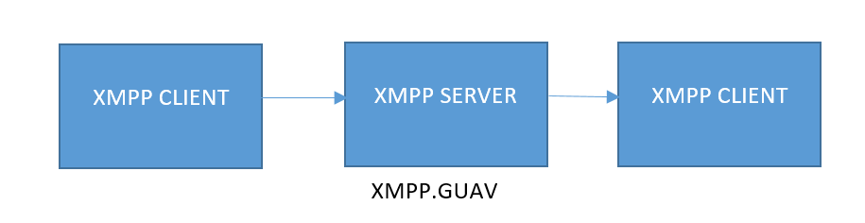

**Figure: Simple XMPP architecture**

There is a more complex architecture as well. Servers are mainly used for the routing purpose between the domains that is from one client to another client. This architecture also includes gateways for the translation of message from a foreign domain and protocols. The block diagram below shows a XMPP network with gateways to a short message services (SMS) and also SMTP domains. The main idea behind the XMPP is to provide universal connectivity among different endpoint protocols. This has made XMPP a universal backbone protocol. The termination of client to server is all controlled by the gateway, and also initiates a new session to the target endpoint protocol.

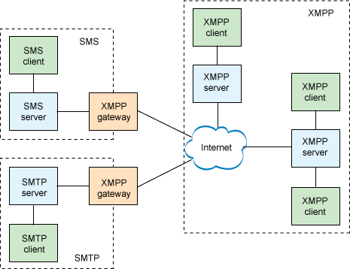

**Figure: Complex XMPP architecture**

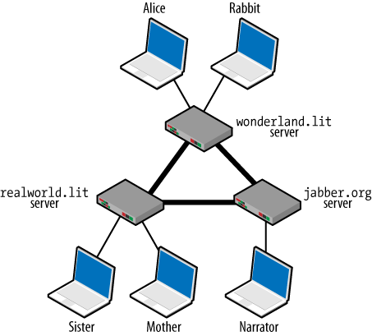

**Figure: Example of XMPP architecture**

The community of XMPP have always tried to simplify the client structure, by making the servers more complex, this has in turn lead to a great innovation in the field of network technology. It is very important in understanding the architectural differences between SMTP, Jabber and web. Whenever a user browses the web, it does not connect to the server directly, but it uses HTML which in turn refers to the server to load the requested information. As a result, the web based communication is not inter-domain communication. Which is in other words termed as the federation. The below diagram shows the federation.

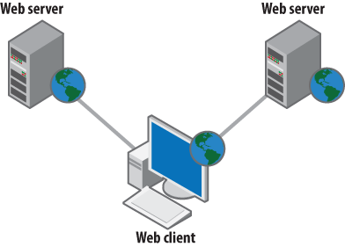

The major distinction between the XMPP and web is that, XMPP has inter domain communications. That is whenever the client or the user sends an XMPP request to any other contact in a different domain, it firsts connects to the home server. The client here connects to the server directly without any HOPS in the middle. This technique is very advantageous in protecting the user from address spoofing and any other malicious activities.

The below figure shows the gives an insight to the basic difference between the web architecture associated with lots of clients and servers along with servers that are interconnected in one HOP.

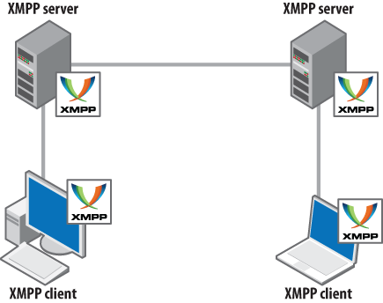

**Address Format for XMPP:**

The XMPP address or jabber ID’s (JID’s) are similar to that of standard e-mail address with some notable changes. JID’s have node (optional), a domain and a resource in the form which is again optional. This can be represented as shown below.

[node “@”] domain [“/” resource]

The XMPP address depends on the DNS (Domain Name System) and not on the IP address. This will help us to use the XMPP very easily without trying to memories the IP address. Here a user using XMPP can login to server multiple times based on the requirements. The main functionality of the resource is to denote the location. For example a user can have a jabber id for his main terminal to be [Avinash.closepet@nationalgeography.channel.guv/terminal](mailto:Avinash.closepet@nationalgeography.channel.guv/terminal)).

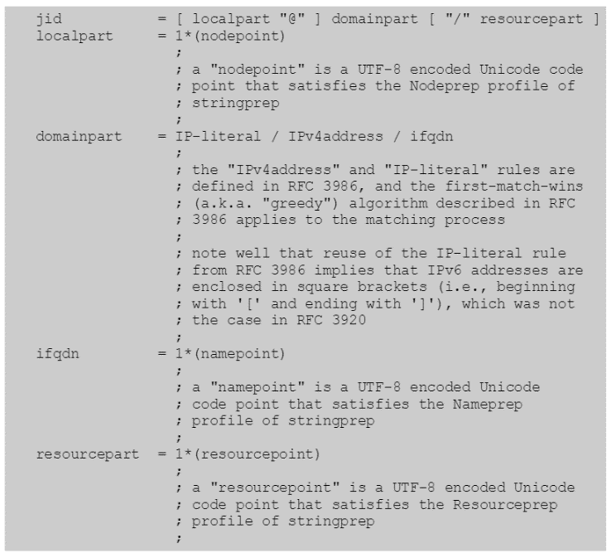

**Figure: XMPP Address format**

**XMPP Connection Cycle:**

The data that are being exchanged is called as a stanza. Mainly there are three types of stanzas they are presence, message and IQ.

**Presence:** This will tell us whether the user is offline or online or status messages.

**Message:** this is nothing but the message or the data sent between the two users.

**IQ:** this provides query based information. Get the user info, update the user info etc.

In order to exchange the data or the stanza we need to establish a stream between a server and a client or a stream between server and a server. Mainly there are four major steps in the life cycle of XMPP. They are Connections, connecting the streams, authentication and disconnection. These four steps are explained in details below with the help of a block diagram.

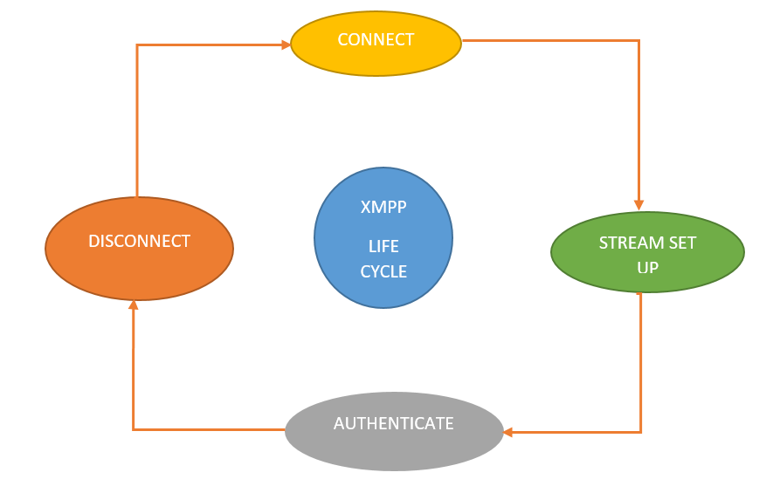

**Figure: XMPP Connection cycle**

**Connection:** in order to establish the streams, a server and a client or server and a server should first establish a connection between them. This is the first and the important step in the XMPP life cycle. Normally when we want a page to be viewed we give the website name and the corresponding IP address is stored in the DNS server. This information present in the server is used to load the page. But in case of XMPP, whenever a client wants to establish a connection with the server, it first has to get the appropriate SRV record. SRV record is nothing but the service record. Once this record is obtained by the client, the connection between the client and the server is established.

**Creating Streams:** Once the connection is established, in order to start the communication, we need to open the streams from both the ends. After this step the server will respond with a tag <stream: stream>. Once the streams are opened on both the sides, the stanzas are now exchanged between the server and the clients. Along with the <stream: stream> tag the server also sends the <stream: features> tag. These tags are mainly used for the authentication and encryption options.

**Authentication:** After the connection and the establishment of the streams we now have to concentrate on authentication. XMPP uses simple authentication and security layers’ protocol (SASL) to authenticate the clients. Clients bound to a particular resource only after authentication is approved. When we are trying to connect two servers, then process for authenticating is little different. Here the TLS certificates are used or exchanged between servers, the recipient server in turn uses the protocol called as the “dial back” to verify the identity of the senders.

**Disconnection:** before starting the communication user would have logged into the system. Once the communication is done or the XMPP session is completed, we have to logout to end the connection this process is called as disconnection. In order to disconnect we use this tag </stream: stream>. After disconnecting the user will be offline or unavailable for any kind of XMPP communications.

**Streaming XML:** For the sessions to be started, TCP connection which is long lived must be enabled and the XML streams must be handled. Once this is done server will also open a stream as a result, one stream in both the direction will be present. The stream is nothing but XML document which is piling up in an incremental order over time. Only once the stream is sent to the server, the XML snippets are exchanged. Mainly there are three snippets

<message/>

<presence/>

<IQ/>

Stanza forms the basic fundamental unit. As the stream is sent to the server, we can send unlimited stanzas as per the requirements. In this XMPP design a client can send multiple request to the server and will be waiting for the reply from the server. The servers reply to all the request as soon as they are flooded with the requests.

**Channel Encryption:** The most important thing in the XMPP is the channel encryption, this mainly uses Transport Layer Security (TLS). This technology is the very much needed technology and compulsory for all the servers and clients that use XMPP. This is used as it overcomes the problem of server identity. This helps in encrypting the traffic on client to server and server to server links, in a straightforward way.

Channel encryption is vulnerable for many attacks, even though we encrypt the message we want to send to our friend or colleague, it remains unencrypted inside the servers, this may lead to a potential risk. Middle man or the server admins can log all our messages as it passes through the network link.

**Authentication:** For the communication to be safe, authentication is very important. In XMPP there are several methods to provide strong identity on the network. The exact credentials are always checked in the process of login. Authentication process make sure that the person in your contact is the same old person added few weeks, months or even a few years back. From address is stamped by the server, this ensures a trust in the message we receive. As mentioned previously XMPP uses simple authentication and security layers (SASL) protocol for authentication. A handshake of authentication with SASL client includes an <auth/> element initially and ends with a <success/> element.

<auth xmlns='urn:ietf:params:xml:ns:xmpp-sasl'  
 mechanism=’*appropriate value here*’></auth>

<success xmlns='urn:ietf:params:xml:ns:xmpp-sasl'/>

At the end once the <success/> element is received, XML streaming is initialized overran existing TCP connection. If there is any failure, then a response message called <failure/> with the exact reason for failure is sent.

<failure xmlns='urn:ietf:params:xml:ns:xmpp-sasl'>  
 <*reason for failure here*/>  
 </failure>

These are some of the main reasons for which the failure message will be generated. They are <aborted/>, <account-disabled/>, <credentials-required/>, etc.

**Error Handling:** If routing an XML stanza to a particular server is unsuccessful, then the server receiving must return an error to the server sending the stanza. If the remote domain name is unsuccessful <remote-server-timeout/> error is returned. But if the server is found and not able to exchange the streams then a <remote-server-timeout/> error stanza is returned. However, a stream exchanged or sent to a intended server is successful but not able to send the stanza to the recipient server, then an appropriate error message must be sent to the sender server.

# XMPP Implementation

**Instant Messaging [IM]**

The initial motive of jabber technology was to deliver a fast messaging platform. Though we consider IM as a person-to-person chat it actually includes sending messages quickly over the network without thinking much about the recipient of the messages. Therefore, XMPP servers are recognized for quick or instant messaging. Suppose user1 at server A sends a IM to user2 at server B. Then first, client of user1 sends message to server A using client-to-server XML stream with no intermediate hops. The server A then captures from and to fields in the stanza without any XML parsing or packet inspection since it consumes lot of time. After seeing that the message is intended for server B the Server A then sends it to the server B by opening server -to server XML stream. Upon receiving the message server B check if user2 is online if yes then it sends it to user2 over server-to-client stream. Note that user1 and user2 should be Presence aware which makes the delivery of messages quick.

During the chat session user requesting the chat sends his full JID for (example omkar@ankur-virtualbox/Spark) along with JID of the receiver (for example ankur@ankur-virtualbox). The receiver then responds with full JID so that they both can exchange messages efficiently. The transitions between the chat states at one of the entities is as shown in the Figure.

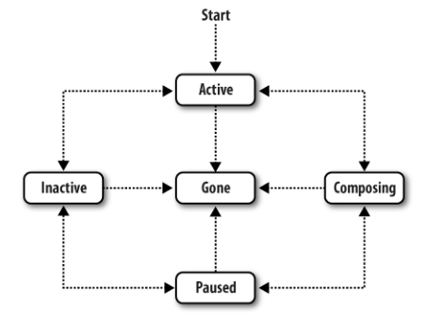

**Figure: XMPP Chat states**

XMPP <message/> tag can contain variety of bodies like mobile data, notifications from cloud services, alerts errors. It consists of sender id receiver id, type of message. The basic format is as following,

<message from='*sender*' id='*sender_id*' to='*receiver’* type='*message_type*'

xml:lang='en'>

<subject>*subject_if_any*</subject>

<body>*message_body*</body>

</message>

Below is an example how Google cloud messaging service uses XMPP to send notifications on cellular phone.

<message id="">

<gcm xmlns="google:mobile:data">

{

"to":"REGISTRATION_ID”, // "to" replaces "registration_ids"

"notification": {

"title": "Portugal vs. Denmark”,

"text”: "5 to 1”

},

"time_to_live":"600"

}

</gcm>

</message>

As shown above we can see that <message/> contains data which is in JSON format.

# Lab Environment setup

**Objective:**

To create a simple Instant Messaging server and capture XMPP packets using the chat server and following entities:

Server: **Openfire** version (4.0.2)

Client: **Spark** version (2.7.7)

Gateway service: **Gtalk** (Google Hangouts)

In order to perform XMPP Lab, we implemented the below steps to build the lab setup:

**Basic Environment Setup:**

**Step 1**:

We downloaded and installed Oracle Virtual boxon windows PC.

<https://www.virtualbox.org/wiki/Downloads>

**Step 2:**

We installed Mint (Linux) on the virtual box with 2GB RAM and 16GB Virtual Disk Space.

<https://www.linuxmint.com/download.php>

**Step 3:**

A network analyzing tool (Wireshark), was installed and updated on Mint using the below commands:

**$sudo add-apt-repository ppa:pi-rho/security**

**$sudo apt-get update**

**$sudo apt-get install wireshark**

**Openfire Setup:**

**Step 1:**

The first check to perform before installing Openfire was to Install Java. We Checked for Installed Java by using the command **$java –version** and found that java was not installed and so installed it using the command **$sudo apt-get install default-jre**

**Step 2:**

Now, we downloaded openfire_4.0.2_all.deb from ignitrealtime.org and installed the downloaded package using **$sudo dpkg –i openfire_4.0.2_all.deb** command.

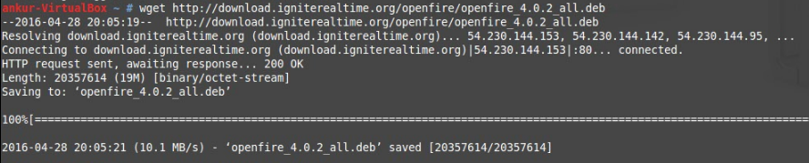

**Figure: Download Openfire**

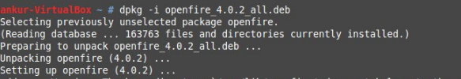**Figure: Install Openfire**

**Step 3:**

Now, as we have installed the openfire server on Linux Mint, the openfire service can be stopped and started from command prompt by using the commands **$sudo /etc/init.d/openfire stop** and **$sudo /etc/init.d/openfire start** respectively.

**Step 4:**

Openfire server is now started on the localhost of the Linux mint machine. We accessed the server by browsing <http://localhost:9090> from the browser and started with the server settings:

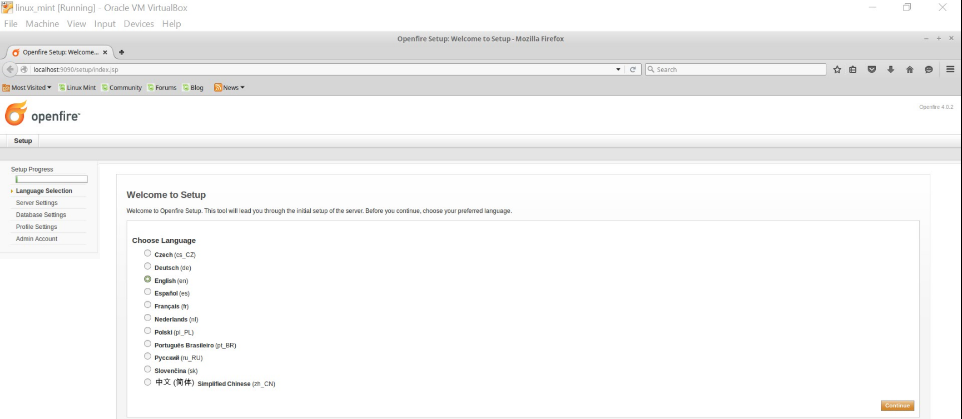**Figure: Server Language selection**

In server settings, domain should be the local host name or the ip address of machine as shown below:

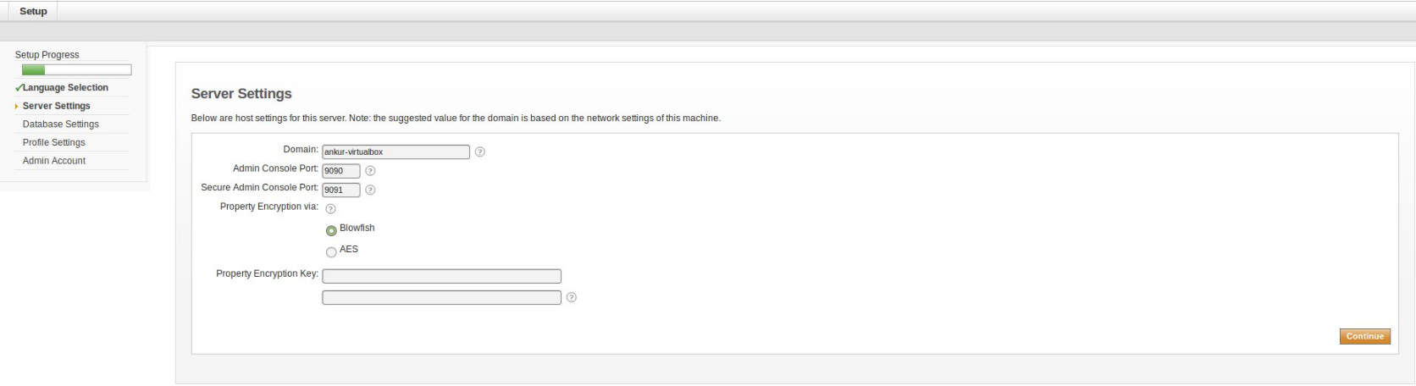**Figure: Server settings**

Since we had planned to capture the XMPP packets for the protocol analysis by simple deployment, we used Embedded database.

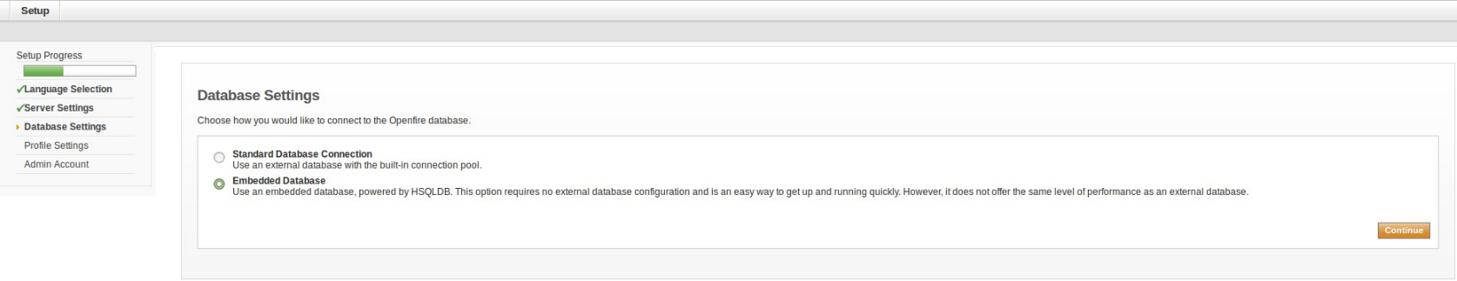**Figure: Database settings**

Since we had planned to capture the XMPP packets for the protocol analysis by simple deployment, we used default profile settings.

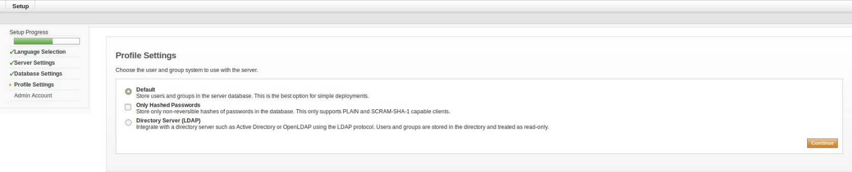**Figure: Profile settings**

Here, the administrator account details are entered, the username and password are used to login to the openfire console.

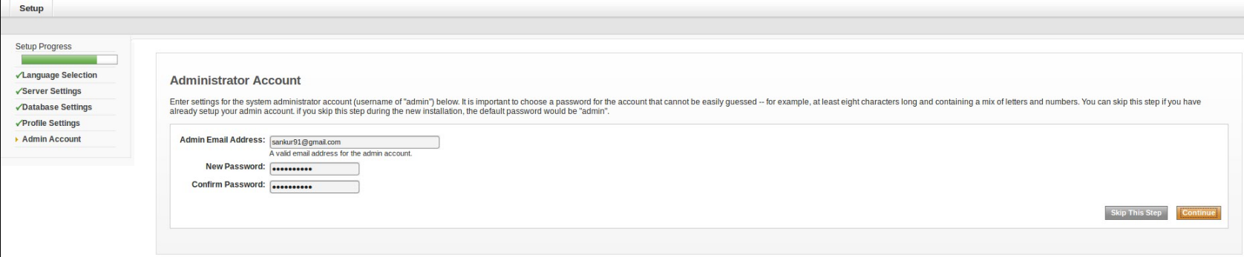**Figure: Administrator Account settings**

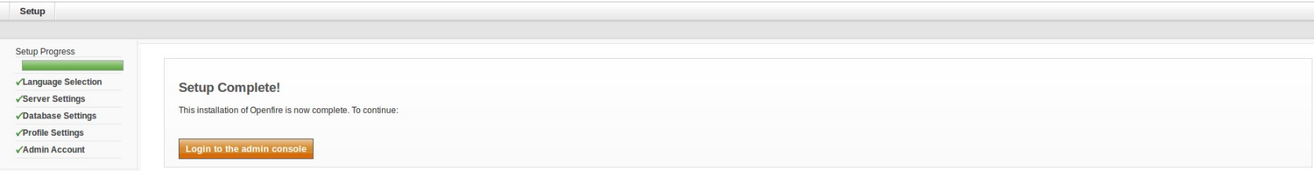**Figure: Openfire Setup Complete**

After the initial setup completion, we logged into the Openfire console using the administrator credentials

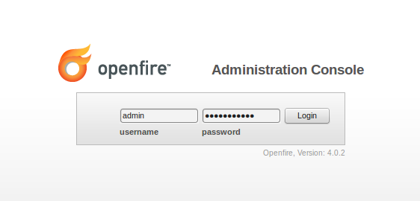

**Figure: Openfire Console**

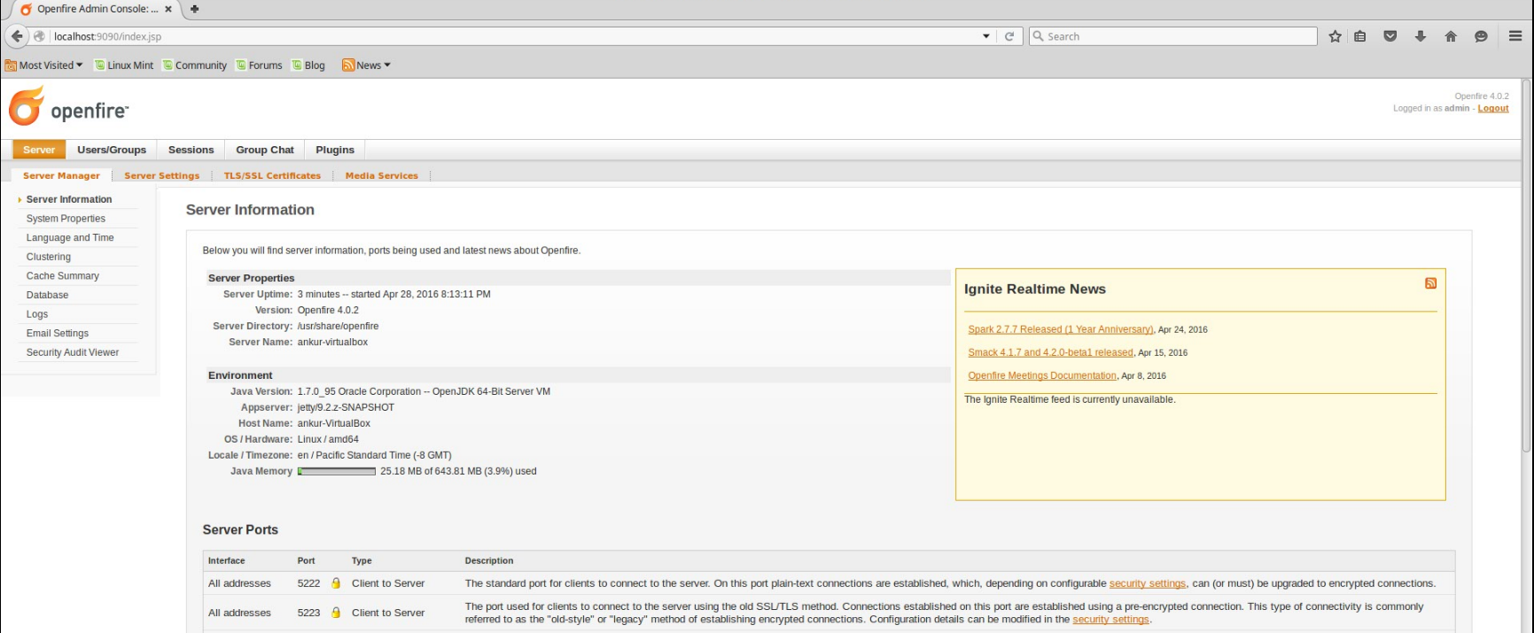**Figure: Server Information**

By using the above setup, we implemented the simple XMPP architecture and captured the required packets using the loopback interface and Wireshark.

**Step 5:**

Now, in order to access public instant messaging networks such as GTalk, IRC, Facebook messenger, AOL messenger, etc., and to explore the complex XMPP architecture, we installed an additional plugin in Openfire, namely Kraken IM Gateway which is used to provide connectivity.

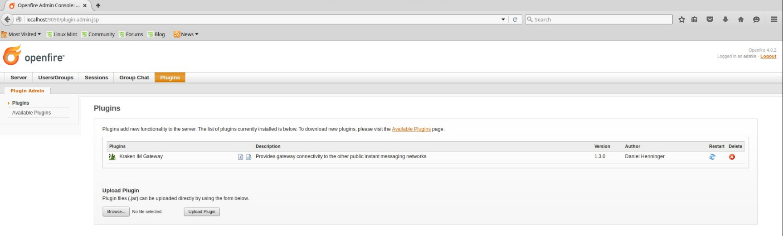**Figure: Installed Plugins (Kraken IM Gateway)**

**Step 6:**

Now,we selected the Gateway Settings by going to Server Tab and then selected Gtalk (Google Hangouts) gateway service and tried the connection to the corresponding server.

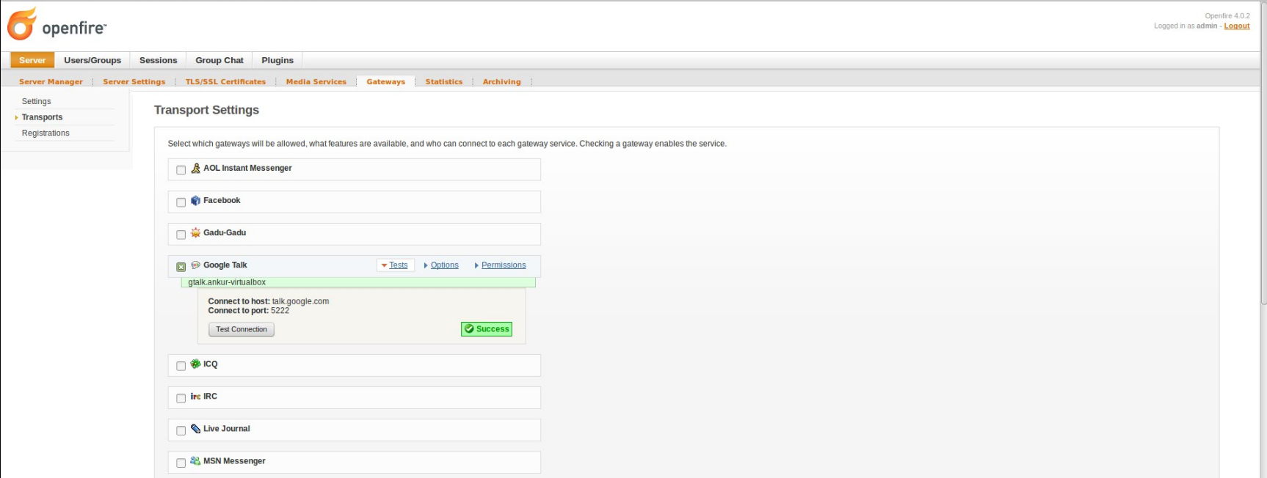**Figure: Gateway service selection (Gtalk)**

**Step 7:**

Now, we added a new registration for Gtalk gateway service using the username and password which can be used to login via Spark Client.

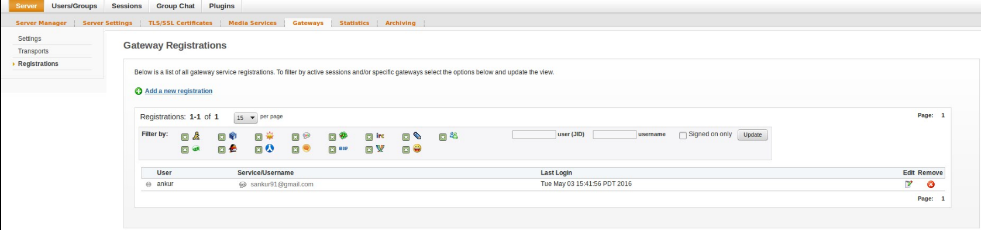**Figure: Gateway registration**

**Note:** For our deployment we selected Gtalk (Google Hangouts) but one can select any gateway service and check the connection to the corresponding server.

**Spark Setup:**

**Step 1:**

Now, to Install Spark IM Client, we download the package spark_2_7_7.tar.gz from igniterealtime.org in in /opt path and unzipped the package using **$ tar –zvxf spark_2_7_7.tar.gz**

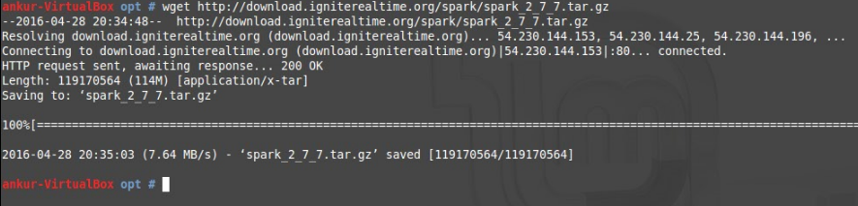**Figure: Download and Install spark**

**Step 2:**

Now, as the spark IM client was installed, we created a desktop entry by which the Client can be accessed by the user in friendly manner by creating a file /usr/share/applications/spark.desktop

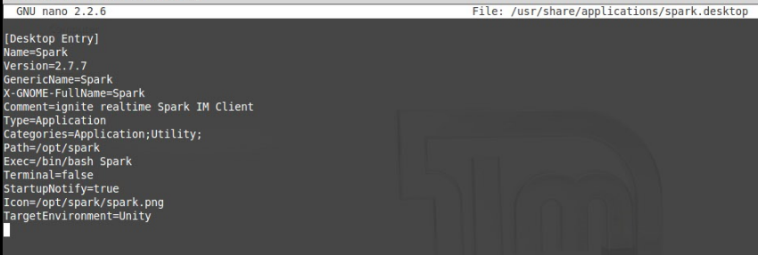

**Figure: Desktop Entry Creation using Nano editor**

**Step 3:**

To get the Icon for the desktop entry we downloaded the Spark Icon (spark.png) in /opt/Spark path as shown:

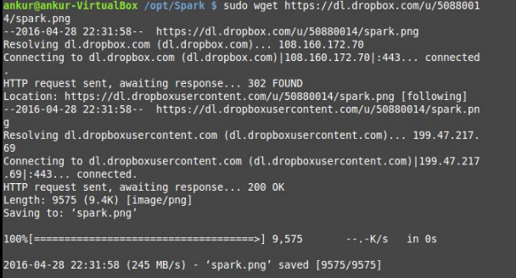

The spark IM Client installation was now complete and we Launched it using the Spark icon on desktop and logged in using the credentials given during Openfire setup. The server here was entered as localhost name or IP address, since it is the name of the Openfire server.

**Figure: Spark Login using Desktop Entry**

**Procedure:**

We captured the XMPP packets for the both the architectures using Wireshark, a network analyzing tool.

* Firstly, we opened Wireshark and kept it running in background to capture the required XMPP packets during Chatting between the two entities.
* By logging into the spark IM client we exchanged the chat messages between two entities and also changed the presence status on the same installed Openfire server.
* Now, we entered the Gmail credentials and tried to communicate using Gtalk service between the two entities, as we had already installed the kraken Plugin along with the Gtalk gateway service in Openfire.
* The captured packets were filtered using the XMPP filter to study and analyze further.
* Various captured XMPP packets and their explanation is described below.

**Protocol Hierarchy:**

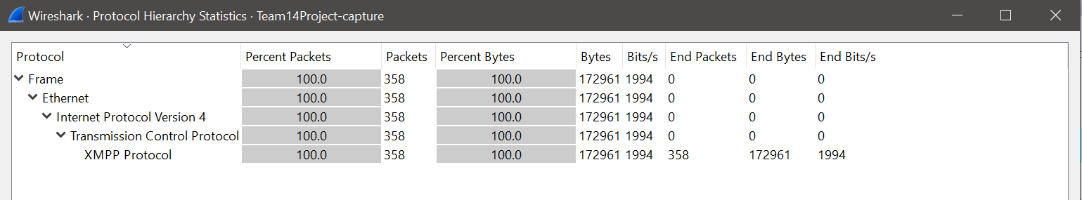

**Figure: Protocol Hierarchy as observed from Wireshark**

**Flow Graph:**

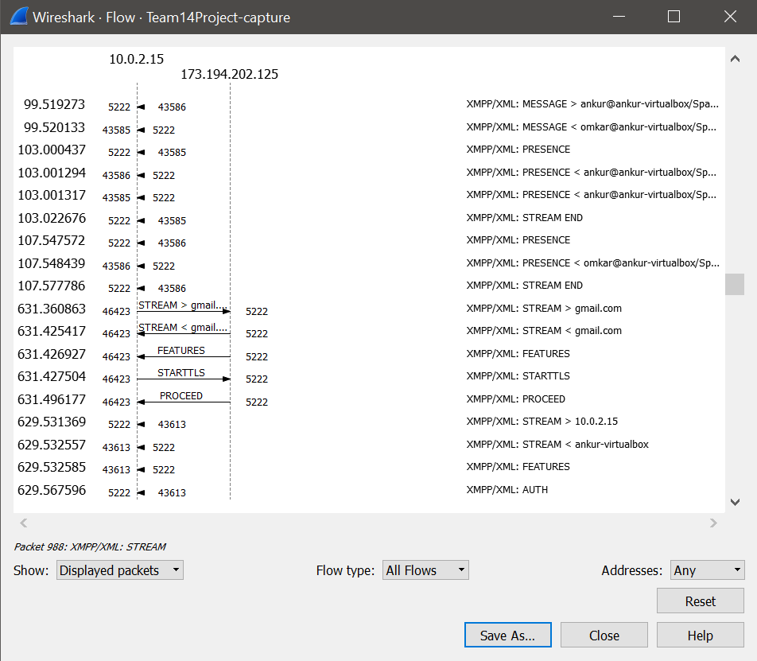

**Figure: Flow graph captured from Wireshark.**

Flow graph explains about the various flow events that take place during the execution of XMPP lab.

# Captured XMPP packets

**Ping Packets**

As protocol states, Client sends an IQ-get containing a <ping/> element qualified by the 'urn:xmpp:ping' namespace. The pinged entity returns either an IQ-result (if it supports the namespace) or an IQ-error (if it does not). In our case it has returned IQ-result as shown below:

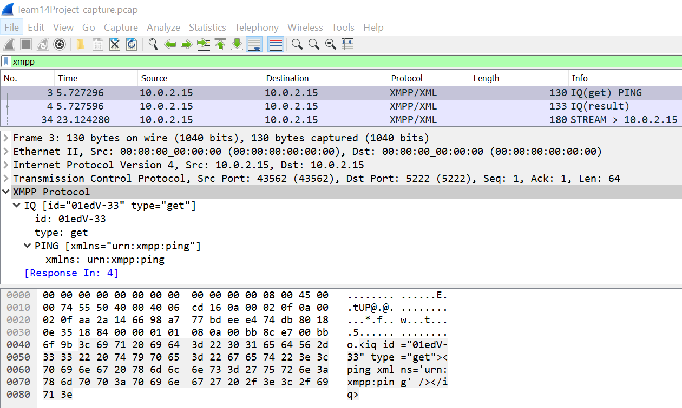**Figure: XMPP Ping packets**

**Stream packets**

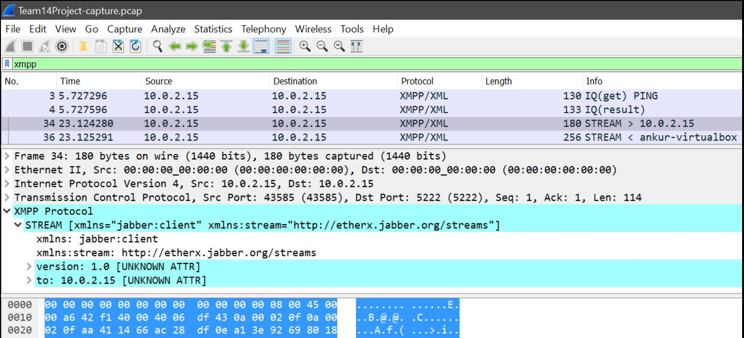**Figure: XMPP Stream packets**

Streams are nothing but the containers for the XML messages passed from both the ways that is from client to server and vice versa. Once the stream is opened from both the ends client as well as server can send XML messages to each other without any interruption.

Later client as well as server will send stanzas to each other over the two streams opened.

**Features packet**

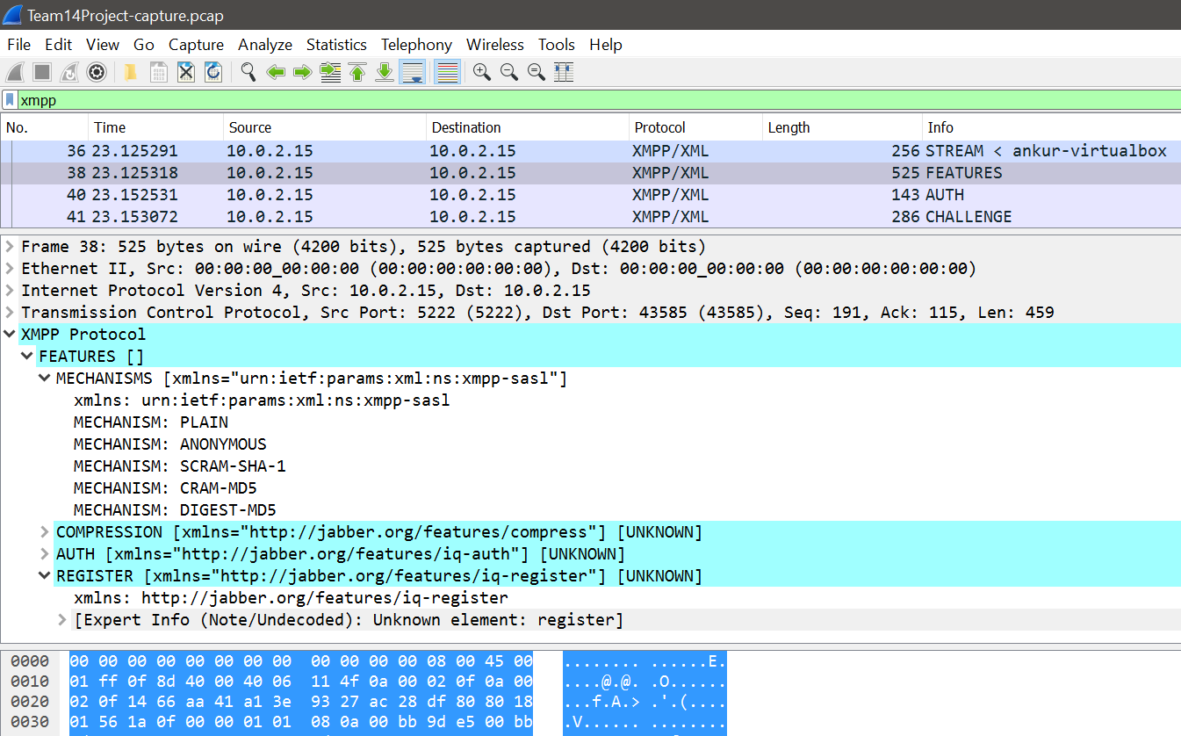

**Figure: XMPP Features packet**

As server has proactively started a stream from Server to Client as well it sends the Stream Features. We can see the features of the stream in Features packets. It specifies SASL mechanisms available for client to choose like DIGEST-MD5, PLAIN etc. under <mechanism/> tag It also provides tag like <compression/> <AUTH/> and <REGISTER/>

**Authentication(Auth) packet**

This is sent from client to server in response to the Feature packet and to notify which authentication it has selected mentioned in Feature.

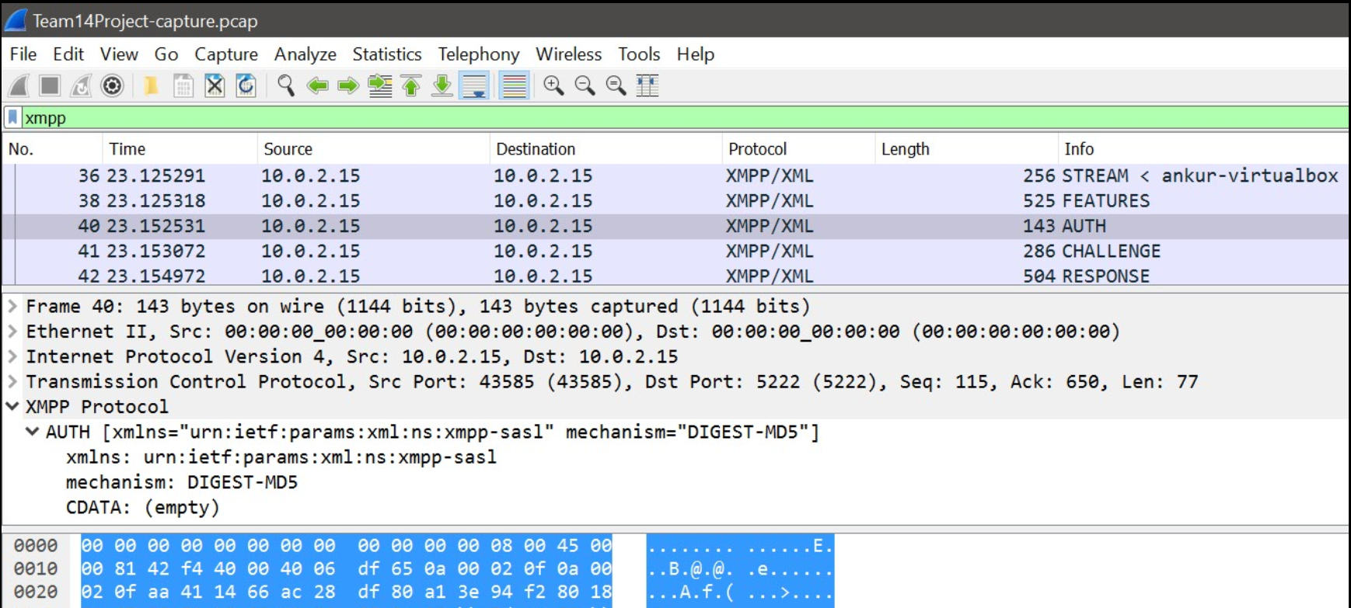

**Figure: XMPP Authentication (Auth) packet**

**Success Packets**

If the server accepts the authorization, it sends back a stream with “success” tag. <success xmlns='urn:ietf:params:xml:ns:xmpp-sasl'/> or: Server: If the password does not match the user name, or there is an error on encoding, the server will sends a failure stream. <failure xmlns='urn:ietf:params:xml:ns:xmpp-sasl'/>

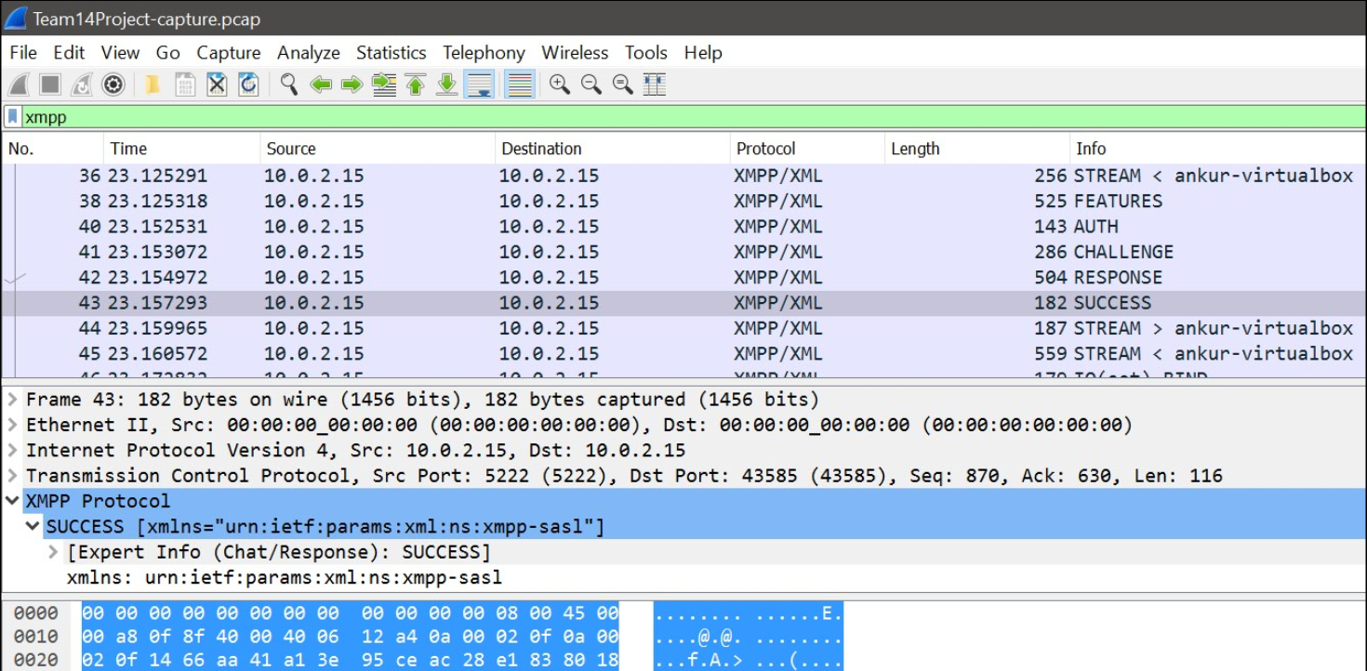

**Figure: XMPP Success packet**

**IQ packets**

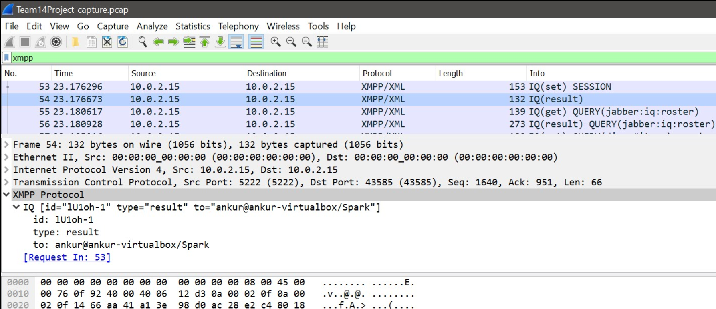

**Figure: XMPP IQ packet**

1.Bind (Type=set)

Client ask a server to bind a resource or itself binds a resource. In our case client itself has bound the resource with name 'Spark' which will be

appended to the JID to give us full JID

2.Result (Type=result)

Server returns full JID to client in response to this in our case it is ankur@ankur-virtualbox/Spark

3. Session (Type=set)

As client binds a resource with server it requests new session to the server.

4. Session (Type=result)

Server sends response specifying whether session is established or not.

5. Query (Type=get)

Now the client in our case omkar@ankur-virtualbox/Spark can query the roster for the other users to have a chat which can be seen in packet

6. Query (Type=response)

Server responds with the roster entries with JID of the user/users. In our case it contains details of the user named ankur with JID ankur@ankur-virtualbox

**Presence Packets**

The client (with JID omkar@ankur-virtualbox/Spark) sends the presence packet to the server and informs server about his status

Server then sends this Presence packet to ankur@ankur-virtualbox

The user2(with JID ankur@ankur-virtualbox/Spark) then sends its status to user with JID omkar@ankur-virtualbox/Spark

These two clients then exchange PRESENCE packets with their status.

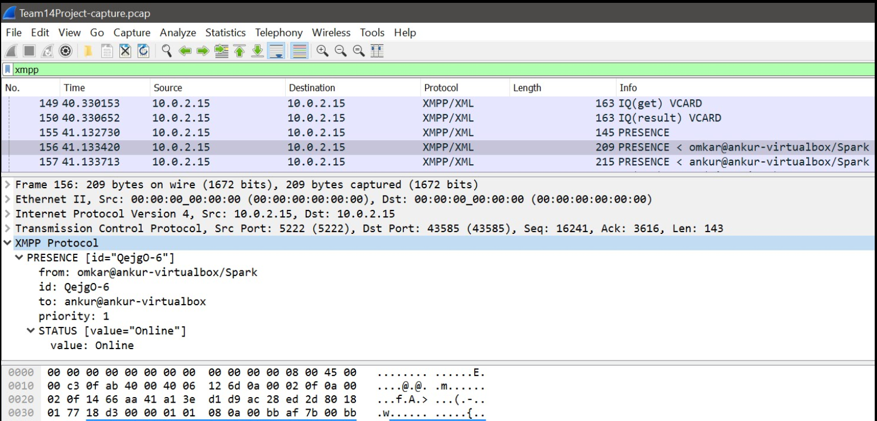

**Figure: XMPP Presence packet**

**Message Packets**

Message packets contains actual text messages to be conveyed to the clients. We can see actual text messages sent in Body of the message.

Message can contain any tag for example in case of cellular notifications it contains notification body in json format.

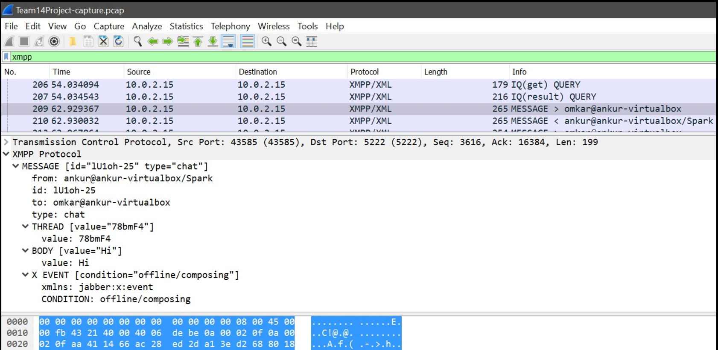

**Figure: XMPP Message packet**

**DNS Lookup Query/response packets**

As we have used Gtalk as a transport while capturing packets in a scenario where XMPP client on our local machine chats with the Gtalk user using Kraken gateway. We have captured DNS packets as shown here where our local machine sends DNS queries to DNS server at 10.10.90.50

and got the google servers IP in response which is 173.194.202.125.

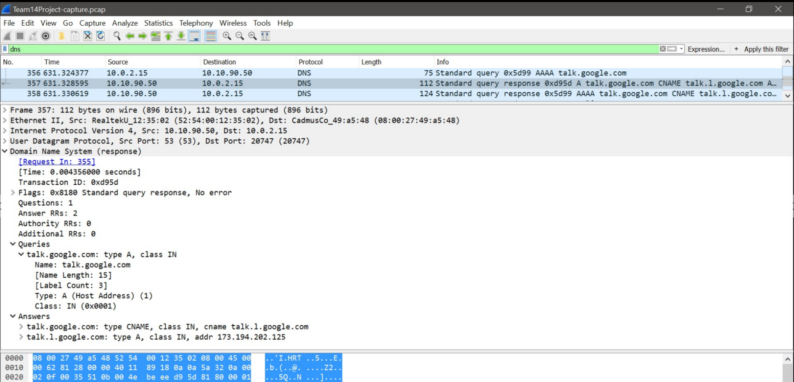

**Figure: DNS Lookup Query**

**SSL/TLS Secure Connection:**

As we can see STARTTLS message has been sent to google server before proceeding to SASL negotiations.

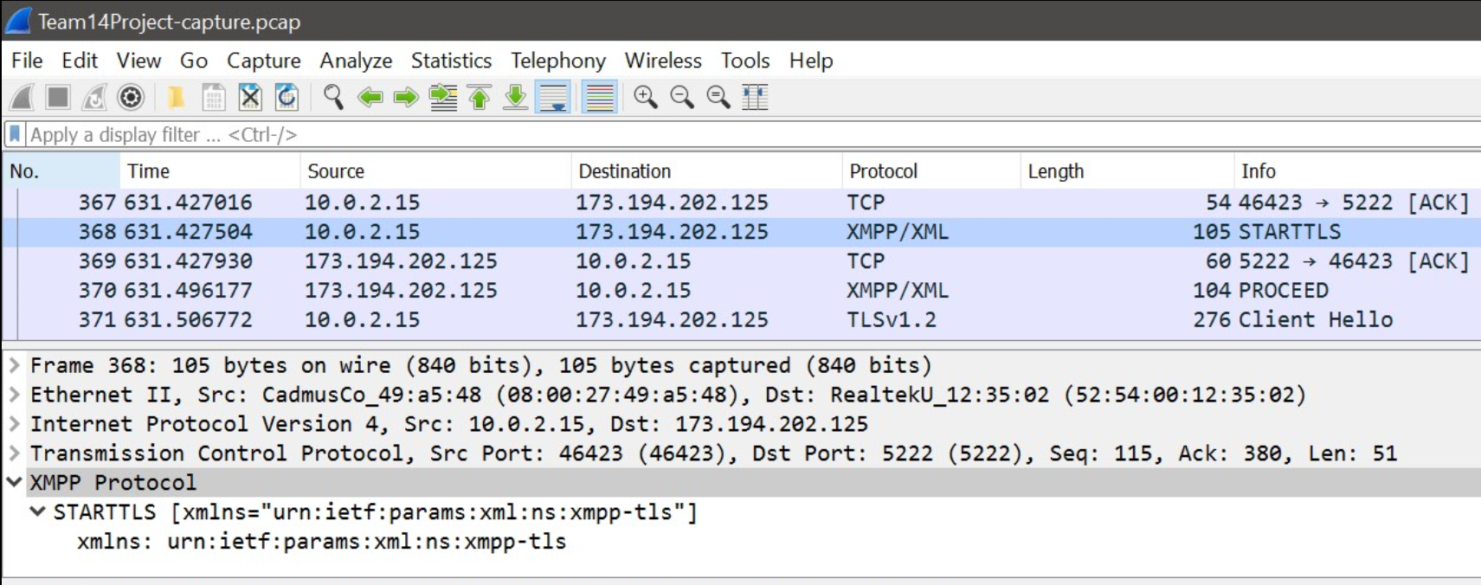

**Figure: STARTTLS Packet**

As described in the report, XMPP uses SSL/TLS protocols for channel encryption and security.

Following are the TLS packets captured during the exchange of XMPP packets in the chat session.

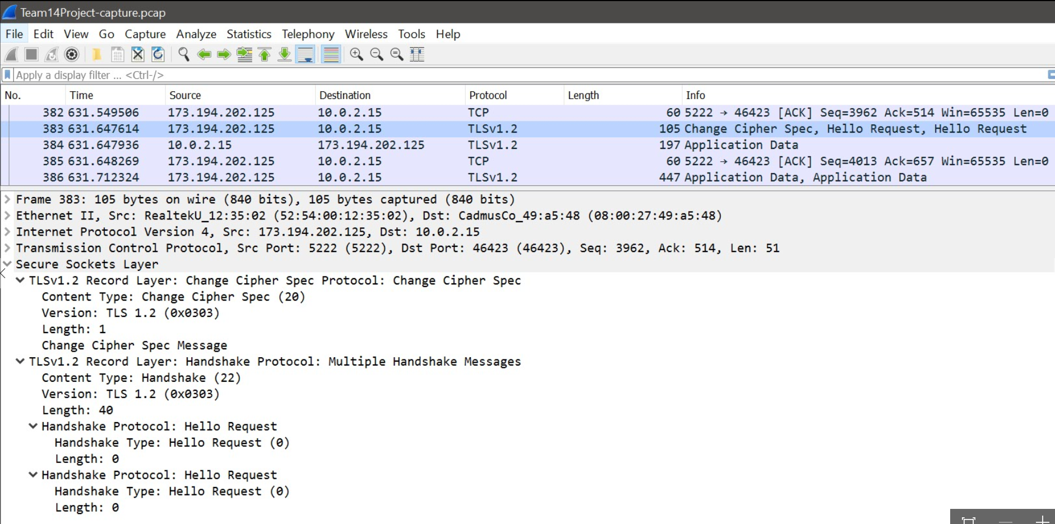

**Figure: SSL/TLS Packet**

**TCP Handshake:**

As we know XMPP uses TCP for binding we can clearly see 3-way handshake over TCP protocol between two entities to set up connection and transmit the data and end the connection.

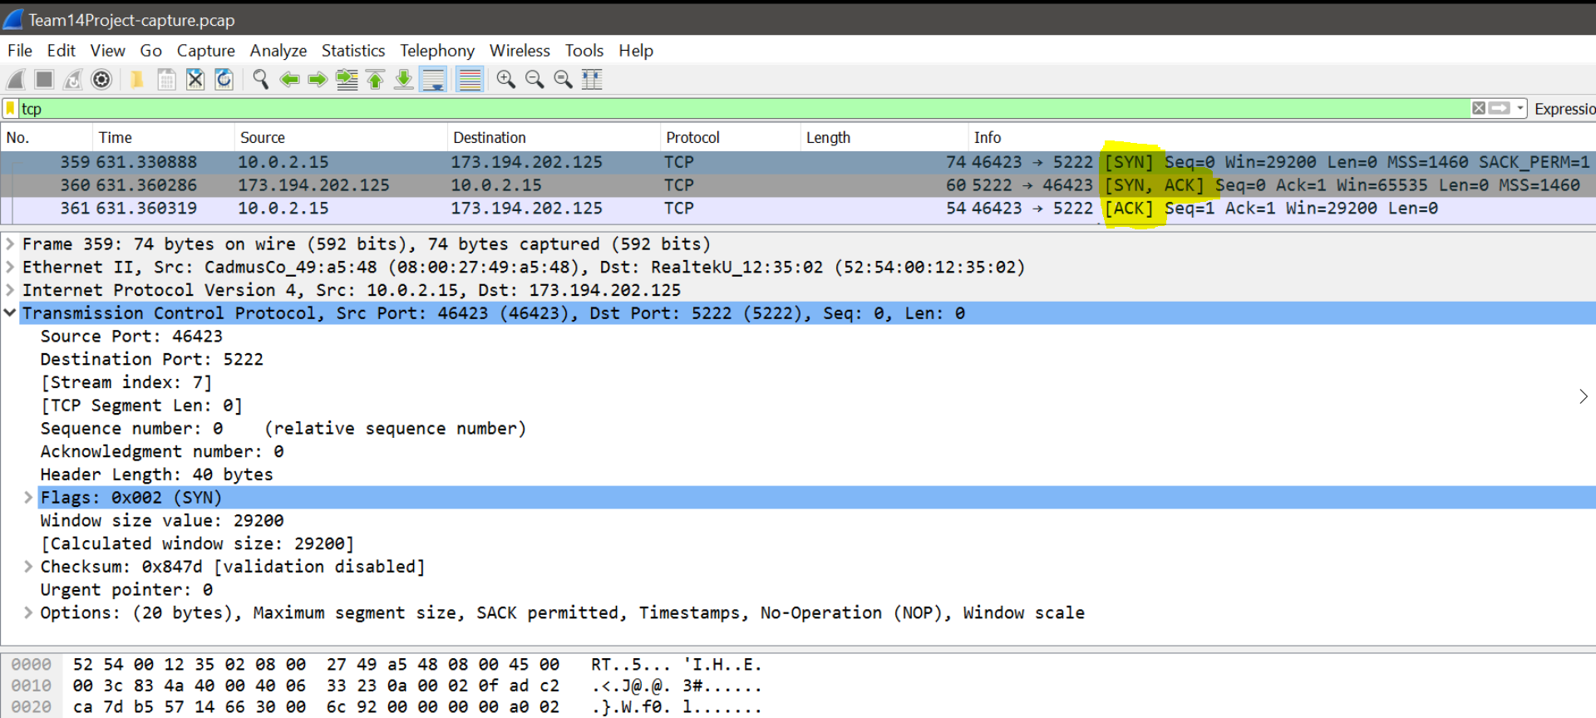

**Figure: 3-way TCP Handshake**

**Advantages of XMPP:**

* Because of it standardized and decentralized nature of XMPP, it is very robust and powerful. It is user friendly, and if a server is turned offline only the clients that are attached to that particular server is affected.
* The architecture of XMPP is almost similar with that of e-mail. The core protocol here is to create a stream, there is no central server.
* Anybody can run his or her own XMPP server, so that individual and organizations can manage their real time messaging.
* XMPP server is independent of the public XMPP network, and safety is provided by using SASL and TLS technology
* XMPP is not only used in real time communication application but also used in network management, content syndication, collaborative tools, and file sharing, gaming and remote monitor.
* The number of available resource and support for XMPP is diverse.
* XMPP is Firewall and Nat Friendly.

**Shortcomings of XMPP:**

* About 60% of the data flow in the XMPP protocol is repeated. Thus XMPP has a large overhead of data to multiple recipients as compared to http
* XMPP cannot modify binary data, as it is coded as a long XML file.
* It is statefull protocol, as a result Programmers find it difficult to code.

**XMPP Standards:**

[RFC 3920]- This explains about the core XMPP

[RFC 6120]- This gives the specifications of the core XMPP.

[RFC 6121]- The specification regarding XMPP IM is given under this standard.

[RFC 6122]- This standard specifies the address format for the XMPP protocol.

**Few Learnings (Outcomes from Project):**

1. We learned the basics of XMPP protocol and its different application.

2. We have also captured the its packets and analyzed their flow using Wireshark.

3. We tested the simple architecture using Openfire and Spark client. We also analyzed Complex architecture with the help of Kraken gateway and Gtalk.

4. We also got hands on Smack APIs to communicate with Google Cloud Messaging Service XMPP endpoint and found that stanzas can also be used for passing other datatypes like JSON format.

# Conclusion

The lab helped the team members in understanding various aspects of XMPP and also gave an opportunity to capture the HTTP traffic using Wireshark for further analysis. The lab helped us in learning the lab environment setup required to perform this lab using Openfire (version 4.0.2) and Spark IM Client (version 2.7.7). We as team found it challenging and interesting to explore and study XMPP, we also understood various features of Wireshark that can be used to get the flow graph, protocol hierarchy, Packet lengths etc. and Finally we were successful in producing a report about XMPP which included the summary of all the aspects that we tried and implemented during the lab execution.

By performing this experiment, we can conclude that XMPP is robust and powerful as its architecture is decentralized. It provides near real time communications through text, audio and video.  Many social networking platforms uses XMPP such as Facebook, WhatsApp, Gtalk and yahoo messenger. XMPP extension protocol (XEP) provides XMPP extension like CAPTCHA, multi-user XEP, Desktop sharing and file transfer. This protocol is secured and provides authentication by using TLS and SASL protocols.

# References

[1] Download VirtualBox. (n.d.). Retrieved April 16, 2016, from [**https://www.virtualbox.org/wiki/Downloads**](https://www.virtualbox.org/wiki/Downloads)

[2] Download Linux Mint 17.3 Rosa. (n.d.). Retrieved April 16, 2016, from [**https://www.linuxmint.com/download.php**](https://www.linuxmint.com/download.php)

[3] [RFC 6120], P.Saint-Andre, “Extensible Messaging and Presence Protocol (XMPP): Core,” Internet RFC 6120, March 2011

[4] [RFC 6121], P.Saint-Andre, “Extensible Messaging and Presence Protocol (XMPP): Instant Messaging and Presence,” Internet RFC 6121, March 2011

[5] [RFC 6122], P.Saint-Andre, “Extensible Messaging and Presence Protocol (XMPP): Address Format,” Internet RFC 6122, March 2011

[6] Peter Saint-Andre, Kevin Smith, and Remko Tronçon, “XMPP: The Definitive Guide Building Real-Time Applications with Jabber Technologies,” April 2009, First Edition.

[7] Downloads. (n.d.). Retrieved May 04, 2016, from [http://www.igniterealtime.org/downloads/index.jsp](http://www.igniterealtime.org/downloads/index.jsp%20)

[8] XMPP vs SIMPLE: The race for messaging standards. (2003). Retrieved May 04, 2016, from [http://www.infoworld.com/t/platforms/xmpp-vs-simple-race-messaging-standards-295](http://www.infoworld.com/t/platforms/xmpp-vs-simple-race-messaging-standards-295%20)

[9] (n.d.). Retrieved from [http://www.ibm.com/developerworks/library/x-xmppintro/x-xmppintro-pdf.pdf](http://www.ibm.com/developerworks/library/x-xmppintro/x-xmppintro-pdf.pdf%20)